**Lab 3**

**Due date**: At the end of your lab period.

No submission online (BS). Show this lab to your lab instructor.

**Purpose**: Demonstrate successfully installing and updating the VM workstation 16.0 pro and **Ubuntu Desktop 20.4.3 ( panter ) as** a virtual machine.

MAC computers: VMware Fusion version 12.0 pro

**Marks:** 10

**Procedure:** The following instructions will guide you through the installation process for VMware **Workstations 16.0 and Linux Ubuntu** 20.4.3

Important Note: In some laptops such as HP, Lenovo, and Dell, the virtualization is not enabled; therefore, you should go to your laptop BIOS and enable it. ( press key F2 or F10, delete)

1-Instruction for downloading and installing VMware workstation 16.0 pro

Login to your **BS (theory section)** and click on **Resources**

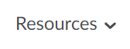

Login to **Algonquin College** with your user id and password





Click on **Continue to Digital Resource Portal**

Click on **Your Software** tab and choose **VMware**

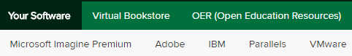

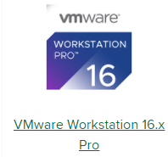

Select **workstation 16.0 Pro** for Windows

Note: for Mac machines choose **VMware fusion 12. x pro**



Click on the **Add to cart** tab

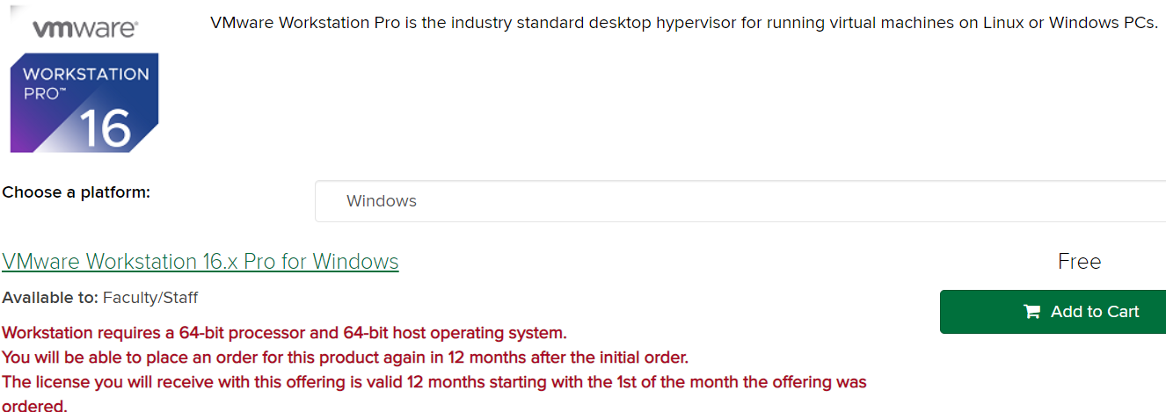

Click on the **Add to Cart** box and choose to **check out**

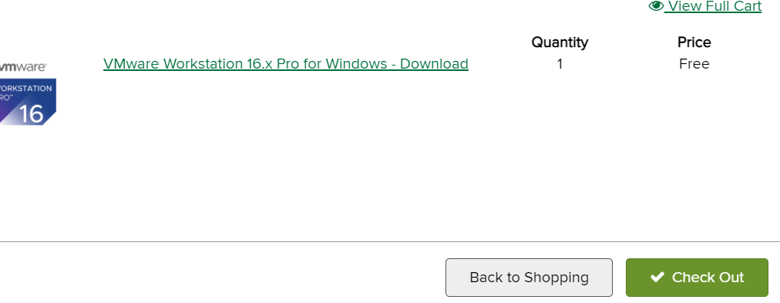

The next screen presents you with the VM **product key.**

Make sure to **save** this **product-Key number**. You need it for later. Example

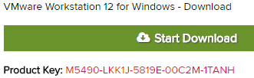

(Important note: Do not change the default directory for download

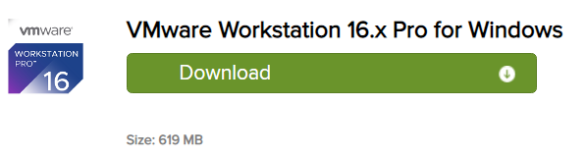

(The Default folder is Downloads)

Click on **Start Download** to **download** the file.

Files size: 619 MB

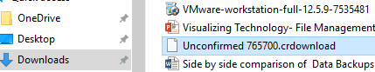

**2-Installing Workstation 16.0 (VMware)**

Locate the downloaded file and launch the application.

(Usually, it is in the **downloads** folder) VMware will load

and the installation wizard will start. Click **next**

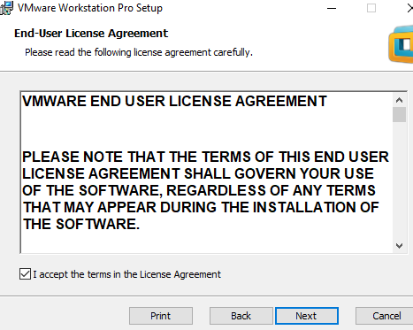

Choose **typical** click **Next**

License agreement click **Next**



Select the folder to install and click **Next**

Select what shortcuts you want and click **Next**.



On the **Ready to perform requested operation** page click **Install**

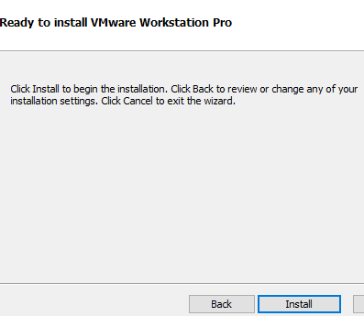

As packages are installed, the status bar will indicate their progress.

Wait for all tools to be installed and do not be impatient if the status

of the bar doesn’t change for a minute or two



Enter the **license key (Red letters)** found on the order sheet you saved. Press **Enter** when you have done this. Now click on **finish**

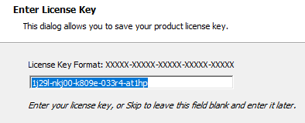

**Updating VMware**

Note: Before you do anything, first check the version of the VM that you have installed.

Open your VM, by clicking on the **VM shotcut ( on desktop)**, click on **Help**, and choose **About VMware Workstation**.

To update your VM: on the summary page, click on **Help** and choose **software update**, then click on the **check for update** tab

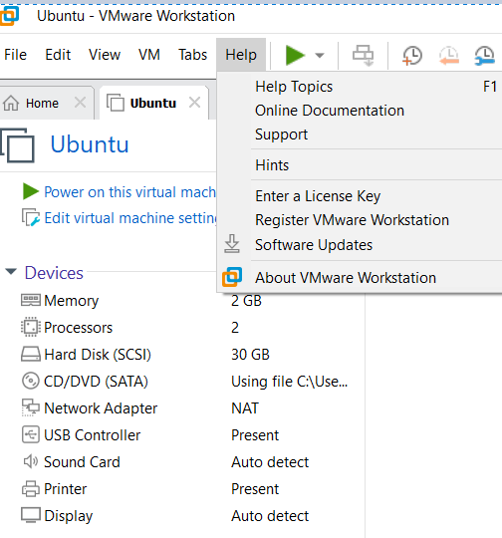

on the software updates page click on the **download and install** box

(Workstation 16.2.2). The process begins to update the VM.

This process takes a long time (more than 10 minutes), be patient

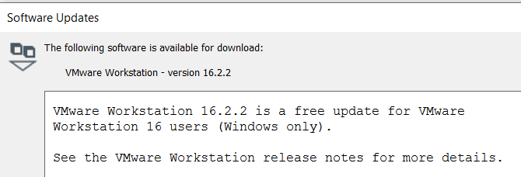

After a few minutes, you will see a workstation 16.0 page with a **next** on it comes on.

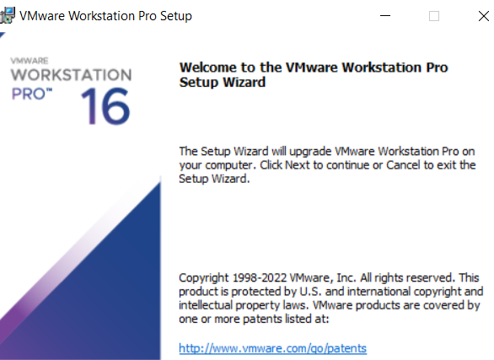

**Do not** click **Next** here, (leave the page as is), just close your VMware by clicking on the **x**



Note: if you click on **next**, in the **Welcome to the VMware** page, you will get a message like the picture, therefore you have to do the process again.

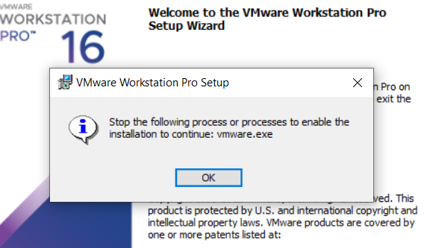

Now go back to the workstation 16 page, (**Welcome to the VMware**) click **Next** and follow the default instructions and finish updating to 16.2.2.



**Creating a Virtual Machine (installing Ubuntu)**

Start VMware Workstation (shortcut on your desktop)



Select **File**🡪**New Virtual Machine**, choose **Custom,** and click **next**

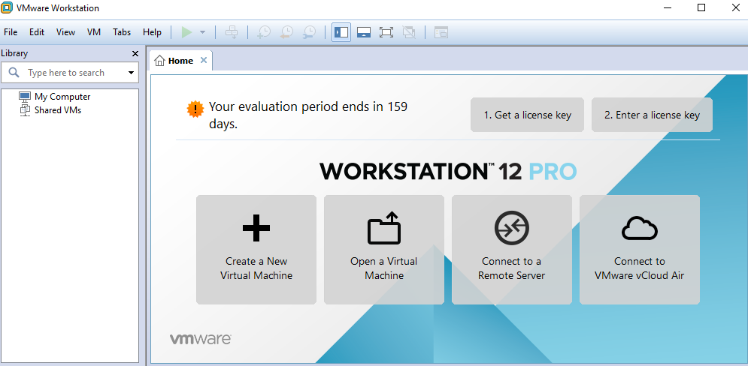

**Click next**

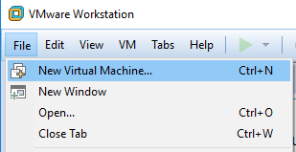

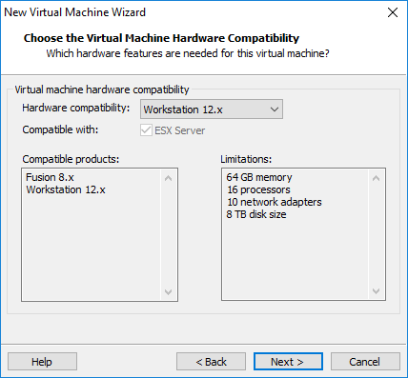

**next**

In the **Guess operating installation** page

Choose **installer disc image files (ISO)** radio button

Then click on the **Browse** tab to find your Ubuntu file

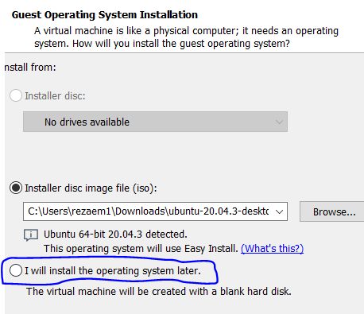

You should see this path (Ubuntu 16.04 desktop-amd64))

Then select **I will install the operating system later radio button** (the same page)



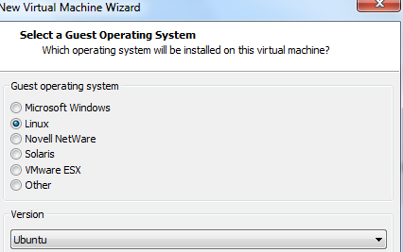

Select **Ubuntu** click **Next**

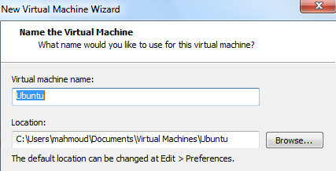

Name the virtual machine **(Ubuntu)**

**Processor configuration** page, keep the **default** value (don’t change anything here) click **next**

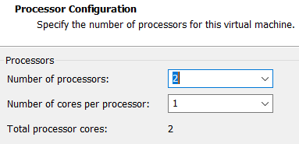

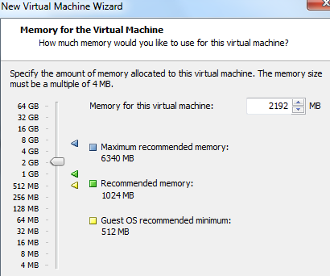

Specify **2 GB** or more of **memory** click **Next**

Network type; keep the default value Use

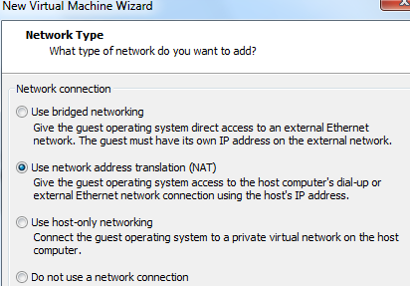

**Network Address Translation (NAT)** and

Click **Next**

**Select I/O Controller types**. Keep the default settings.

Click **Next**

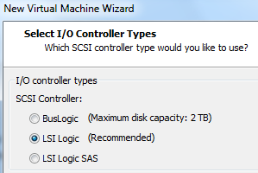

**Select a Disk Type**. Keep the **default** setting (SCSI).

Click **Next**

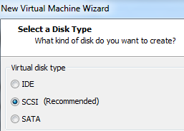

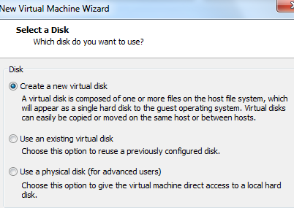

**Select a Disk** (default)

**Create a New virtual disk**

**Specify Disk Capacity** set **the Maximum disk size (GB**): Field to **30**

**GB**. Keep the default **Store virtual disk as a single file** option. Click

**Next**





**Specify Disk File**. Keep the default settings. (i.e. Ubuntu.vmdk)

Click **Next**

**Ready to Create Virtual Machine**, Verify the information in the

table is correct and if so click **Finish**. Otherwise, click the **Back**

button and make corrections.



The **summary** page for the Ubuntu virtual machine is now visible

Follow part 4

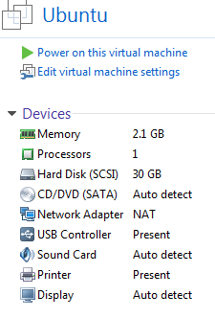

**Summary page**

**3-Downloading Ubuntu 20.4.3 (version panter)**

Go to <http://www.ubuntu.com/download/desktop> and download **Ubuntu 20.4.3** to a directory on your local hard drive. (**Download folder**)



**4- Installing the Ubuntu image (ISO) file (Linux)**

Install ISO image file to the Ubuntu virtual machine:

From the **Summary,** page (Virtual Machine Setting),

double click on the **CD? DVD (SATA**) device. This brings

up the virtual Settings dialog

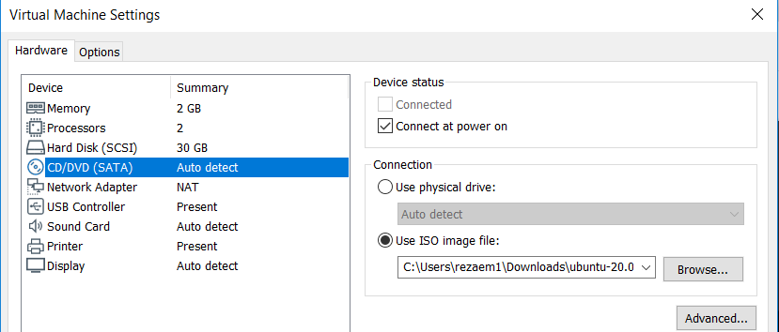

In the **Virtual Machine setting** dialog box under

**Connection**, select the **Use ISO** image files radio button and **browse** to the location of the Ubuntu ISO (**downloads** folder) file. Highlight the file and, click **Open** and then **OK**

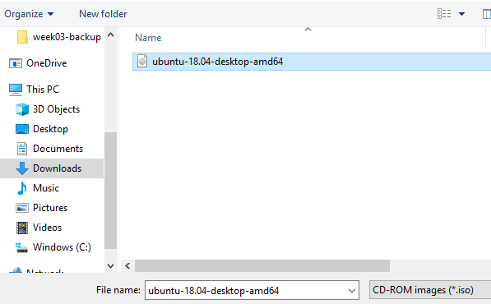

Under Ubuntu click on **power on this virtual machine** to turn on the virtual machine

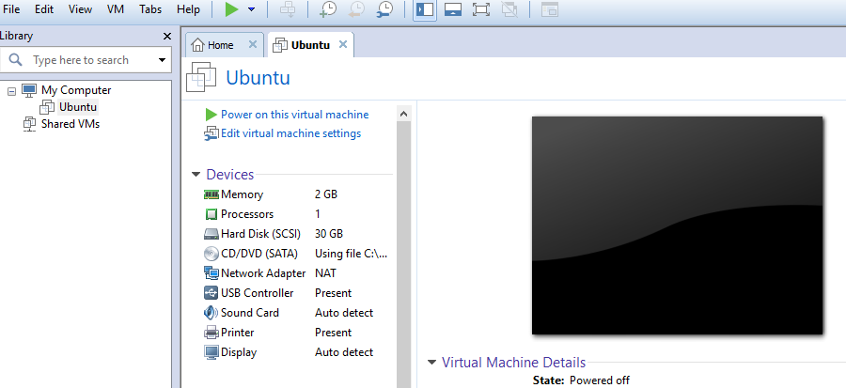

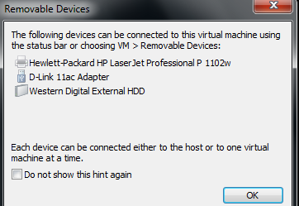

Note: If you see this page just click **ok**

**Note**: if you got a black screen with a slash that is spinning,

That means the virtual machine did not find the **Ubuntu file**.

In your VM machine on the menu bar (blue color), click on

the **VM** tab choose **Power,** and click on **Power off**

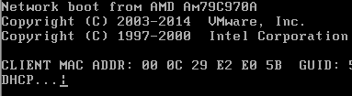

**Shut off** your virtual machine**.**

Go back to the **summary** page and under **connection** select

**Use ISO image** file again click on **browse** and locate your

**Ubuntu ISO image** files, highlight the Ubuntu file and click **Open,** and then **OK**

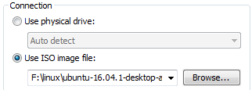

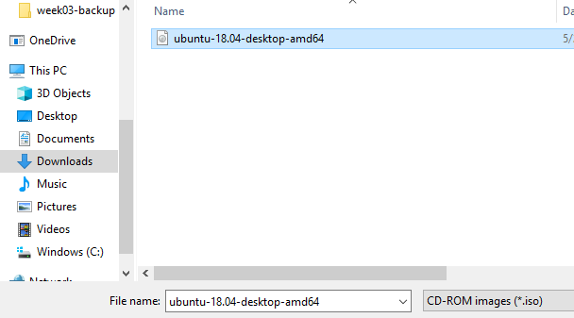

**5- Installing Ubuntu into the Virtual machine (custom installation)**

In the **Ubuntu** tab, go to the **Commands** section and

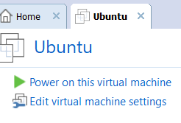

Click on **Power on this virtual machine**. If a pop-up window

emerges about the "keyboard hook timeout", click **OK**

on the **Welcome** page click on the **Install Ubuntu** tab



Choose **Linux to** click next

In the **Preparing to install Ubuntu** page just click **Continue**

**Installation type,** choose **something else,** (custom installation)

Click **Continue**

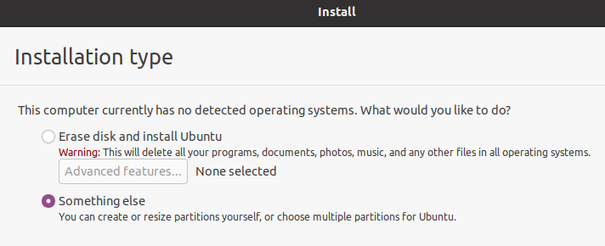

In the **installation type**, click on the **New partition table**



You may get this message, click **Continue**



In the **installation Type** unde**r free space (orange)**

Click on the **plus + sign**

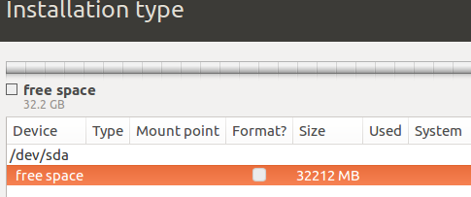

Create partition choose these settings:

Size: **20 000**MB (20 GB)

Type for the new partition: **Primary**

Location for the new partition: **Beginning of the space**

Use as **Ext4journalling** file system

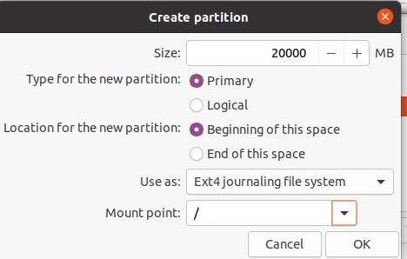

Mount point**: / (root) (exam)**

Click **OK**

Highlight the **free space** again and click on the **Plus + sign**

To create a **swap area** partition (virtual memory) (exam)

Swap partition: a portion of a **disk drive** serves as an extension of the main memory.

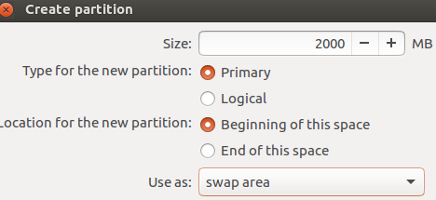

Size: **2000** MB (2 GB)

Type for the new partition: **Primary**

Location for the new partition:

**Beginning of this space**

Use as: **swap area**

Click **OK**

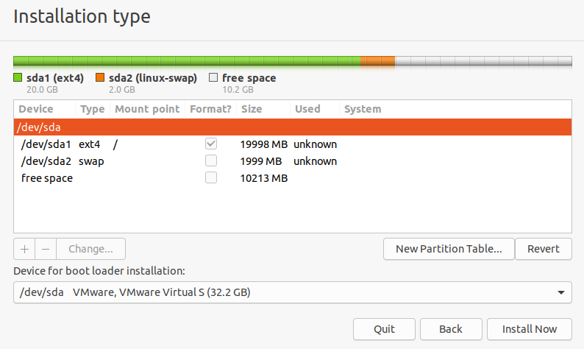

Click on **Install Now**

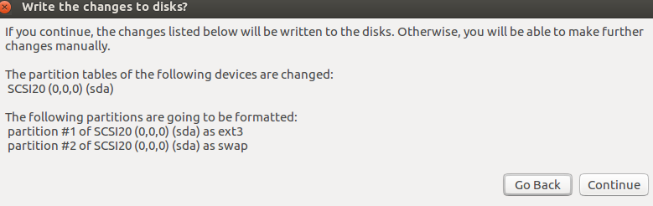

Warning: **write the change disk?**

Click **Continue**

W**here are you**? Type: **Toronto** and click **continue**

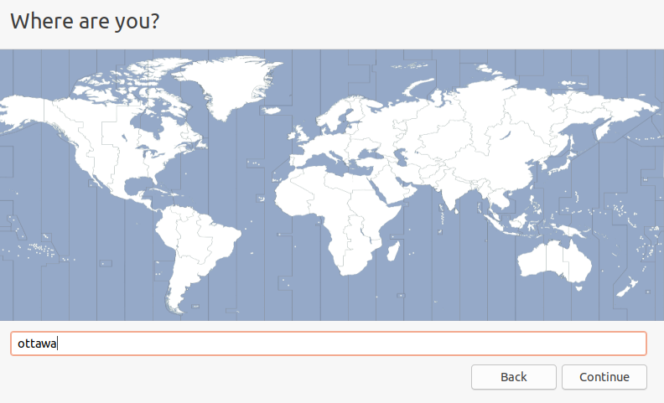

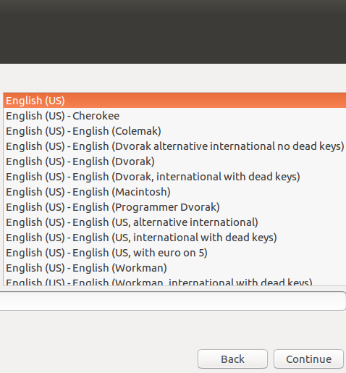

Keyboard layout **English**, click **Continue**

**Note:** If you do not see the **Continue** tab

Move your mouse on top of the screen (the black/gray area)

and move the page to the **left.** You should be able to

see the **Continue** tab now.

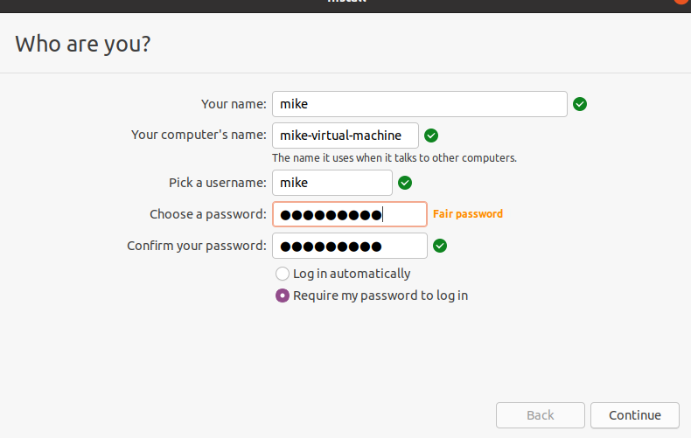

**Setup the username**

Provide a username and password

Go to the default settings

Click **Continue**

**Welcome to Ubuntu** screen begins to install the **Ubuntu** files

**Note:** this part takes a few minutes

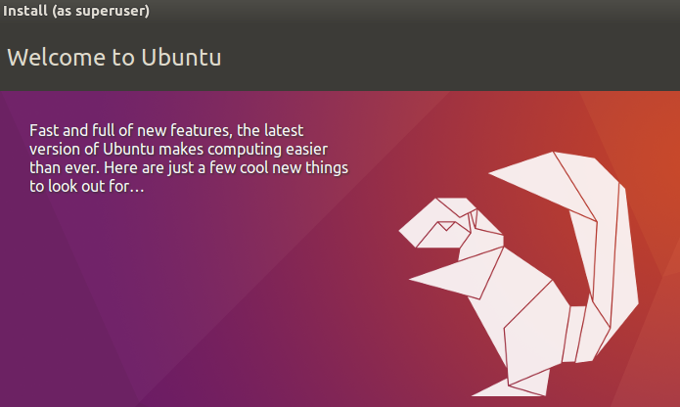

Once Ubuntu is finished, it would ask you to restart your machine

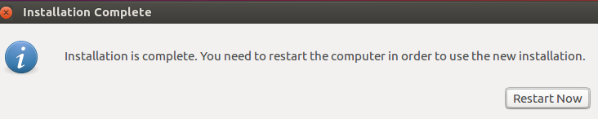

Just click on **Restart now**

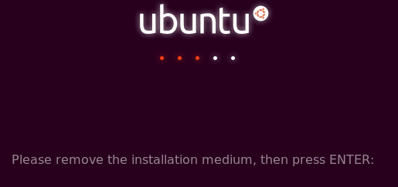

You are done**. Press Enter**

**Note**: When the new operating system boots, you **may/may not**

see errors such as these. If so, click **I Finished Installing**

on the bottom of the **Ubuntu** tab in VMware Workstation.

Click on the error screen and press **1** to reboot, or **power off/on** the

Ubuntu again, be patient…

Ubuntu should boot normally. When the Ubuntu boot screen

Appears, click on the account you have created, and log in as that user.

**Important note**: if you are missing your mouse inside of your computer

(Virtual machine) just press **Ctrl+Alt (exam)**



**6-Update Ubuntu Linux**

Open your Ubuntu, choose **show Applications,** and then click on the **software update**





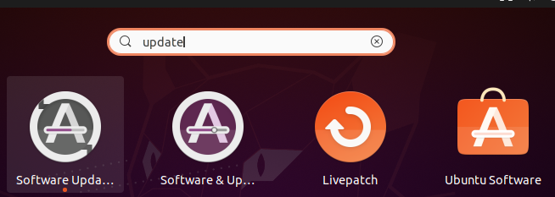

Click on Software update

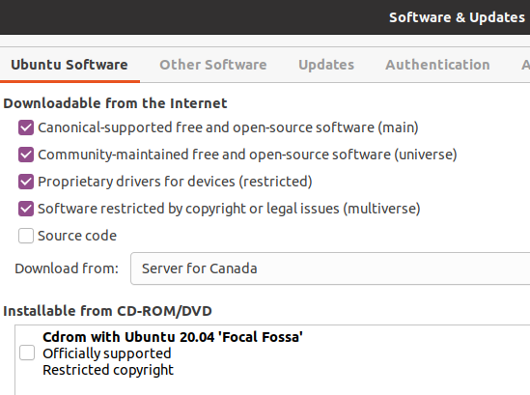

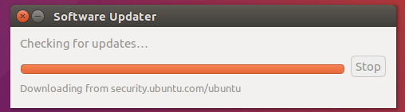

**You are done.**

**How to Uninstall VM ( if you have a problem with ubuntu)**

If you have a problem with your VM machine, (Ubuntu) and you want to uninstall it compleletly, then follow these steps.

1-In Windows, go to the **Control panel**, choose **program and features**, click on **change,** and click on the **Remove** tab.

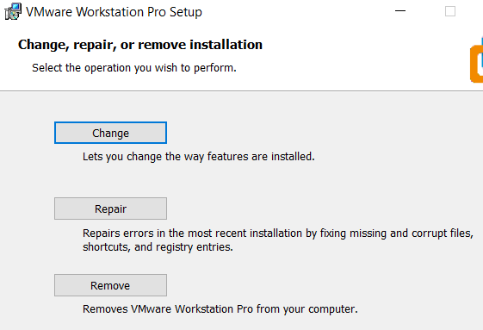

Follow the default instructions and remove the program.

2- Go to the **file explorer** (bottom of your screen) choose the **Documents** folder, find the **Virtual machine** folder. Right-click on it and Delete the folder.



3- Go to **This PC** and find the **C:\** drive. Click on the **program files X86** folder and delete the **VMware** folder.

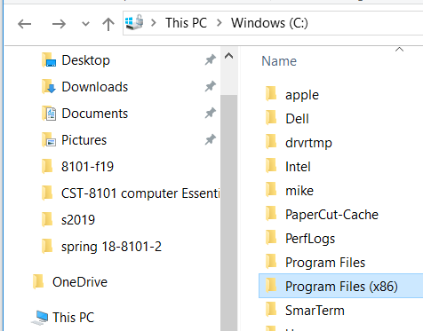

4- **Reboot** your computer and start to reinstall the VM and Ubuntu again.